1- Past this code to any .js file like bundle startup.js file

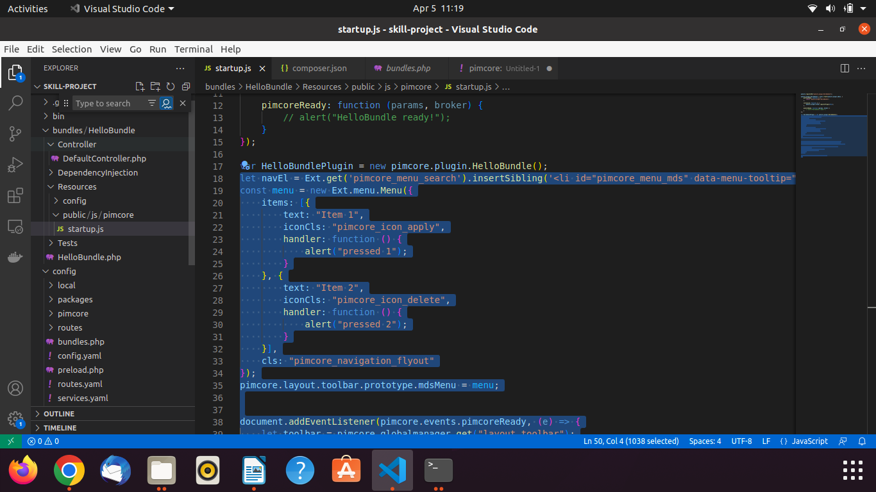

let navEl = Ext.get('pimcore_menu_search').insertSibling('<li id="pimcore_menu_mds" data-menu-tooltip="mds extension" class="pimcore_menu_item pimcore_menu_needs_children">mds extension</li>', 'after');

const menu = new Ext.menu.Menu({

items: [{

text: "Item 1",

iconCls: "pimcore_icon_apply",

handler: function () {

alert("pressed 1");

}

}, {

text: "Item 2",

iconCls: "pimcore_icon_delete",

handler: function () {

alert("pressed 2");

}

}],

cls: "pimcore_navigation_flyout"

});

pimcore.layout.toolbar.prototype.mdsMenu = menu;

document.addEventListener(pimcore.events.pimcoreReady, (e) => {

let toolbar = pimcore.globalmanager.get("layout_toolbar");

navEl.on("mousedown", toolbar.showSubMenu.bind(toolbar.mdsMenu));

const mdsMenuReady = new CustomEvent("mdsMenuReady", {

detail: {

mdsMenu: toolbar.mdsMenu,

type: "document"

}

});

document.dispatchEvent(mdsMenuReady);

});

2- After saving run some command if it is not working

bin/console assets:install public

bin/console c:c

3- Finally you can see like this

